**Resolving parsys height issue**

To add parsys in sightly template need to add the following code

<div data-sly-resource=”${‘parcontent’ @ resourceType=’wcm/foundation/components/parsys’}”/>

but after adding that you will able to see the parsys on the page but not able to add the components to that parsys, see the below figure

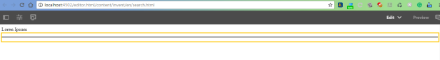

to resolve this problem, we need to add the below code to our rendering component htl.

By adding tbelow code we are initializing Experience Manager authoring UI.

<sly data-sly-include=”/libs/wcm/core/components/init/init.jsp” data-sly-unwrap/>

and add one property to component node to inherit the properties of page component as below

**name: sling:resourceSuperType**

**type: String**

**value: wcm/foundation/components/page**

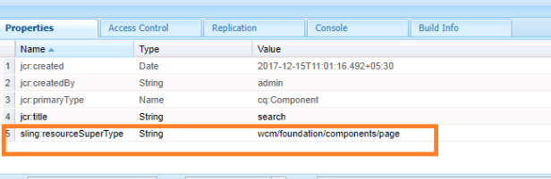

after adding code lines as mentioned above, will be able to see the parsys and also can be able to add the components.

